EightBitz’s Dungeondraft Tools

Table of Contents

Getting Started 3

Tag Assets 4

What Does it Do? 5

Important Details 5

Folder Organization 5

Colorable Assets 5

The Controls 5

Source Folder 5

Default Tag 8

Send output to TagAssets.log 8

Folders to Tag 8

Start 8

Final Notes 9

Convert Assets 9

What Does it Do? 10

Important Details 10

Converting Organized Asset Folders 10

Converting Non-Asset Folders 11

The Controls 12

Source Folder 12

Destination Folder 12

Send output to ConvertAssets.log 12

Start 12

Convert Packs 12

What Does it Do? 13

Important Details 13

The Controls 13

Source Folder 13

Destination Folder 13

Remove working folders after conversion 13

Send output to ConvertPacks.log 13

Pack Files to Convert 13

Start 14

Copy Assets 14

What Does it Do? 15

Important Details 15

Multiple File Versions 15

Portals 16

The Controls 16

Source Folder 16

Destination Folder 18

Create Tags File 18

Separate Portals 18

Send output to CopyAssets.log 18

Pack Assets 18

What Does it Do? 19

Important Details 19

The Controls 19

Source Folder 19

Destination Folder 19

Asset Folders to Pack 20

Start 20

Unpack Assets 20

What Does it Do? 20

Important Details 20

The Controls 21

Source Folder 21

Destination Folder 21

Pack Files to Unpack 21

Start 21

# Getting Started

Most people just want to be able to generate a default.dungeondraft_tags file. If that’s all you want to do, then you need to download DDTools.exe and Newtonsoft.Json.dll.

You can download both of those files from <https://github.com/EightBitz/Dungeondraft-Tools>

Some people want to be able to convert assets to .webp format. This program uses ImageMagick to perform that conversion. You can download ImageMagick from <https://imagemagick.org/script/download.php#windows>

Make sure you get the latest 64-bit version for Windows.

Some people want to be able to convert pre-packed files to .webp format, or to otherwise unpack and repack files. For that, this program uses dungeondraft-unpack.exe and dungeondraft-pack.exe. You can download those files from <https://github.com/Ryex/Dungeondraft-GoPackager/releases/tag/v1.1.0>

I also try to keep them updated on my GitHub page, so if it’s easier for you, you can download them there. Again, that’s <https://github.com/EightBitz/Dungeondraft-Tools>

To recap, you will need the following files, all in the same folder.

* DDTools.exe
* Newtonsoft.Json.dll
* dungeondraft-pack.exe
* dungeondraft-unpack.exe

And you will need to install the 64-bit version of ImageMagick.

Once you have all that in place, double-click DDTools.exe, and you will be greeted with the following window.

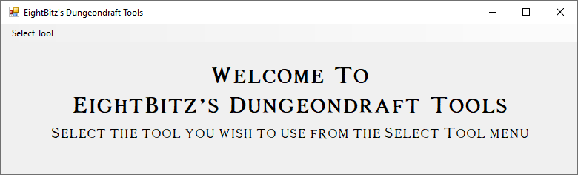

From there, you can click the “Select Tool” menu to see your options.

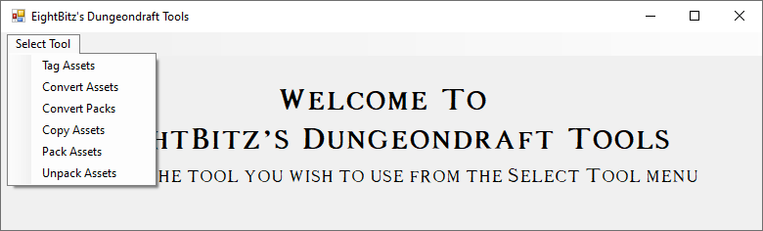

# Tag Assets

This will present you with the interface for the Tag Assets Tool.

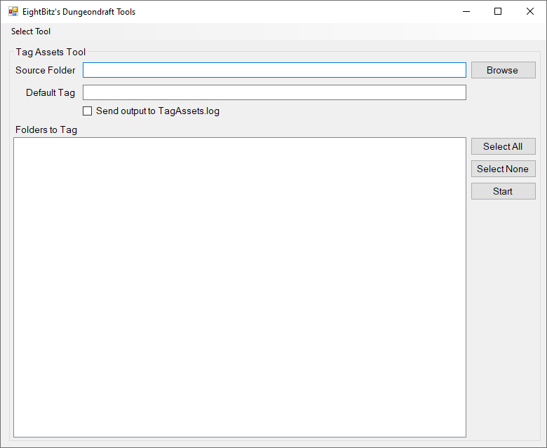

## What Does it Do?

For people who want to create their own custom asset packs, the Tag Assets tool will create a properly formatted default.dungeondraft_tags file. This is the file that Dungeondraft uses to determine which assets in the object library are associated with which tags.

## Important Details

This tool requires that NewtonSoft.Json.dll reside in the same folder as DDTools.exe.

### Folder Organization

In order to benefit from this tool, your folders should be organized into subfolders. For instance, say you keep all your asset folders in a parent folder named “MyAssetFolders”

Within “MyAssetFolders”, you might have folders named “CityPack”, “DungeonPack” and “ForestPack”.

Within each of those three folders, you will have a “textures\objects” path.

Within the “textures\objects” path, you can organize your assets into subfolders. For instance, you might have the following subfolders:

“ForestPack\textures\objects\Animals”

“ForestPack\textures\objects\Bushes”

“ForestPack\textures\objects\Trees”

The Tag Assets tool will use these subfolders as your tags. In this case, your tags will be “Animals”, Bushes” and “Trees”. Anything files within those subfolders will be assigned to those tags, respectively. If you have subfolders for different types of trees, those files will still be tagged as “Trees”. For instance,

“ForestPack\textures\objects\Trees\dead”

“ForestPack\textures\objects\Trees\evergreen”

“ForestPack\textures\objects\Trees\fruit”

Anything within any of these deeper subfolders will still be tagged as “Trees”.

### Colorable Assets

Anything within a “Colorable” folder will be tagged as colorable. For instance, anything within “ForestPack\textures\objects\Animals\Colorable” will be tagged as both “Animals” and “Colorable”.

Anything within “ForestPack\textures\objects\Animals\Friendly\Colorable” will be tagged as both “Animals” and “Colorable”.

If you want something tagged as colorable, you can put it in its proper category, but make sure to place it in a “Colorable” folder within that category.

## The Controls

### Source Folder

Using the example folders specified above, if I selected “MyAssetFolders” as my source folder, the tool will look for any folders within “MyAssetFolders” that have a “textures\objects” path. In this case, those folders will be “CityPack”, “DungeonPack” and “ForestPack”. Those three folders will appear in the checklist.

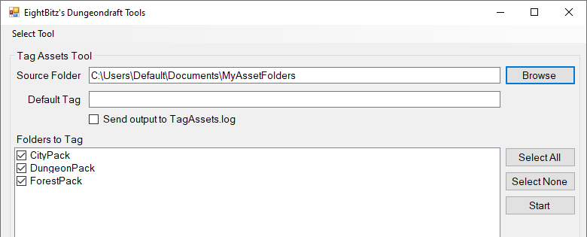

Alternatively, you can select one, specific folder as your source folder (as long as it contains a “textures\objects” path). Say, for instance, you select the “CityPack” folder.

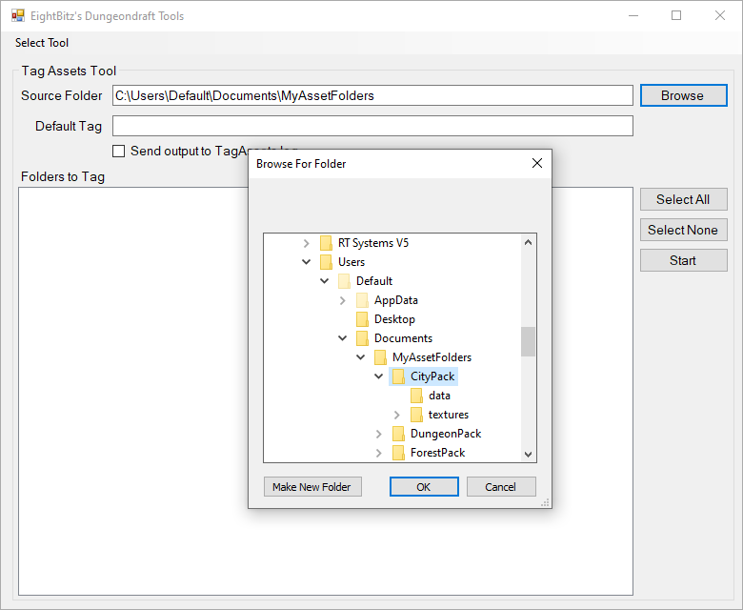

The tool will add that folder, and only that folder (ignoring the others) to your checklist.

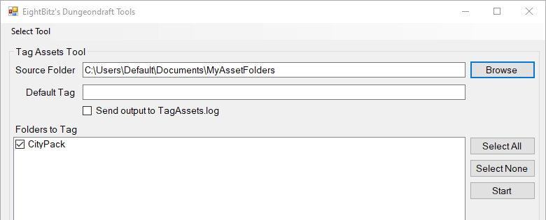

### Default Tag

If you have any files that you just don’t want to put in any subfolders, you can opt for a Default Tag for those files. Anything in “textures\objects”, but not in a subfolder, will be tagged with the default tag.

If you leave the Default Tag blank, any files that are not in subfolders will not be tagged.

### Send output to TagAssets.log

This will save output to a log file named “TagAssets.log”, in the same folder as DDTools.exe.

### Folders to Tag

When you select your source folder, any folders within it that have a “textures\objects” path will appear in this checklist.

### Start

Once you’ve selected all your other options, click “Start” will begin the tagging process. A new window will pop-up with a brief log of sorts.

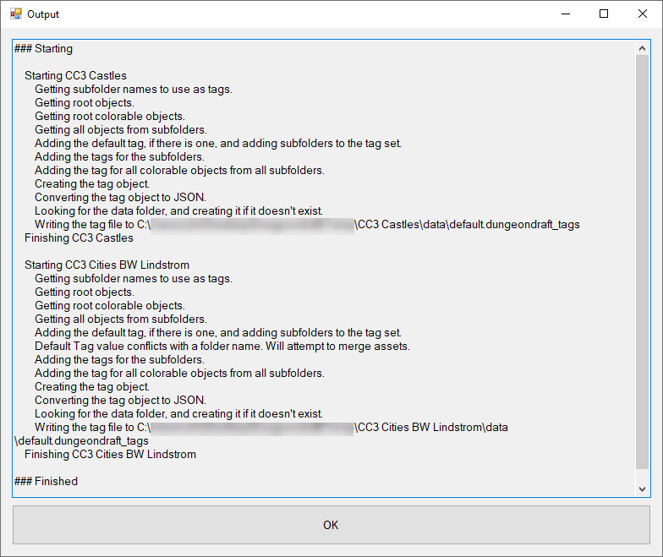

## Final Notes

The name of the asset folder will be used as the name of the tag set. For the “CityPack” folder, the tag set will be named “CityPack”. For the “DungeonPack” folder, the tag set will be named “DungeonPack”, etc.

The resulting tags file is written to where it should be. For “CityPack”, it will be written to “CityPack\data\default.dungeondraft_tags”. For “DungeonPack”, it will be written to “DungeonPack\data\default.dungeondraft_tags”.

If the data folder does not exist, it will be created.

If there is an existing default.dungeondraft_tags file, it will be overwritten.

If there is an existing data folder, and there are other data files (for walls or tilesets), those data files will remain intact.

Consider this a beta. When it’s done doing its thing, take a look at the resulting files, and make sure things look OK.

Create the actual Package(s) with Dungeondraft, load them up, and make sure the tags are working.

# Convert Assets

This will present you with the interface for the Convert Assets Tool.

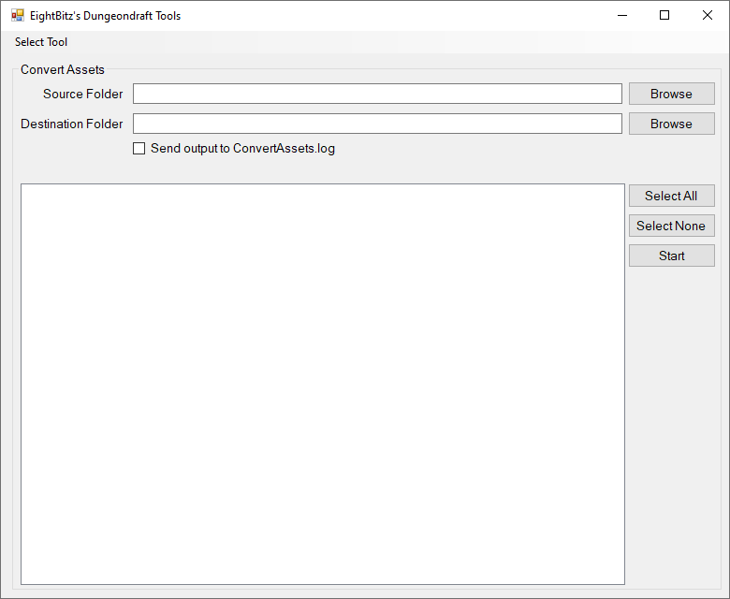

## What Does it Do?

The Convert Assets tool will convert supported image formats in selected folders to .webp format. .webp offers lossless compression, so the files on disk end up being smaller. That being said, this will not save resources in Dungeondraft, as when .webp files are loaded into memory, they are uncompressed.

I added this function at the suggestion of someone on the Dungeondraft Discord server. Whether or not you find it ultimately beneficial, I will leave to you.

## Important Details

This tool requires ImageMagick to be installed.

### Converting Organized Asset Folders

Dungeondraft supports .webp images in the objects library, but not for other types of assets (e.g. walls, tilesets, materials, et al).

If you are converting an asset folder that is already organized as a Dungeondraft asset folder, this tool will recognize that. It will only convert images in the textures\objects folder. All other images will be copied instead of converted.

All data and metadata files will be copied as well. All default.dungeondraft_tags files will be updated to reflect the extension for converted files.

Also, this tool does a recursive conversion, meaning it will find all subfolders within the folder you select. This is particularly important to note if you want to convert a folder that’s organized as an asset folder. In that case, you want don’t want to drill down into the actual asset folder.

You want to stop at the point where you see your asset folder names in the list, like this:

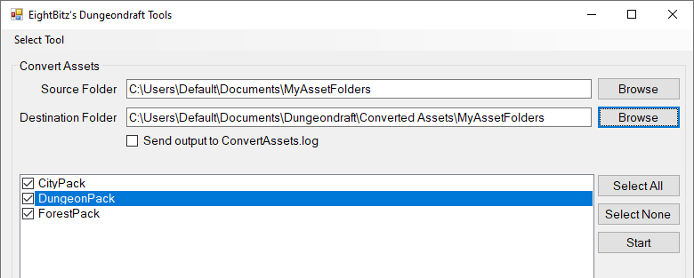

You can go higher than that if you want, but not lower.

You don’t want to go into your asset folders where you see the textures and/or data folders.

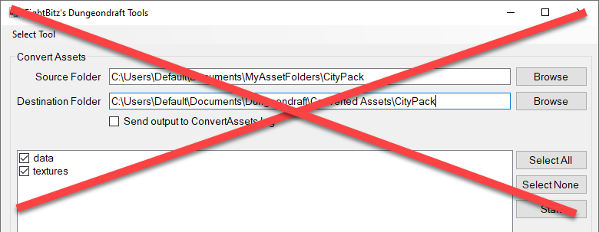

If you do drill down into an individual asset folder, the textures folder will be converted, but the data folder will be ignored. I may workout how to fix this later, but for now, be aware.

### Converting Non-Asset Folders

If you convert a folder that is not organized as an asset folder, all supported image types will be converted to webp, and all other files will be ignored.

## The Controls

### Source Folder

This specifies the folder that contains the folders and files you want to convert.

### Destination Folder

This specifies the folder that will contain the converted files.

### Send output to ConvertAssets.log

This will save output to a log file named “ConvertAssets.log”, in the same folder as DDTools.exe.

### Start

This begins the conversion process.

# Convert Packs

This will present you with the interface for the Convert Packs Tool.

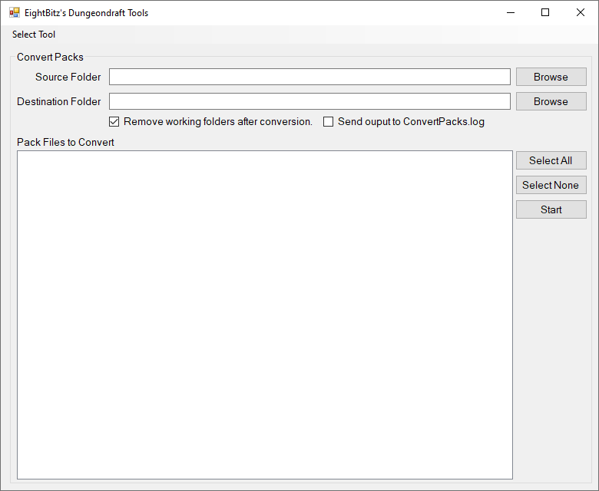

## What Does it Do?

This works similar to the Convert Assets tool, except it works on files that are already packed. This tool calls dungeondraft-unpack.exe to unpack selected files, then it calls ImageMagick to convert assets to webp, then it repacks the converted asset folders.

## Important Details

This tool requires ImageMagick to be installed.

This tool also requires that the following files reside in the same folder as DDTools.exe

* NewtonSoft.Json.dll
* dungeondraft-unpack.exe
* dugneondraft-pack.exe

## The Controls

### Source Folder

This specifies the source folder that contains the asset packs you want to convert.

### Destination Folder

This specifies the root folder that will contain the converted packs.

### Remove working folders after conversion

While this program runs, it creates three folders in the destination path. It creates an “Unpacked Assets” folder, a “Converted Folders” folder, and a “Converted Packs folder.

When it finishes, by default, it removes the “Unpacked Assets” folder and the “Converted Folders” folder. It basically cleans up after itself.

If you want to leave those folders in place, uncheck this box.

### Send output to ConvertPacks.log

This will save output to a log file named “ConvertPacks.log”, in the same folder as DDTools.exe.

### Pack Files to Convert

When you select the folder that contains the packs you want to convert, the packs will show up in the listbox as checkable items.

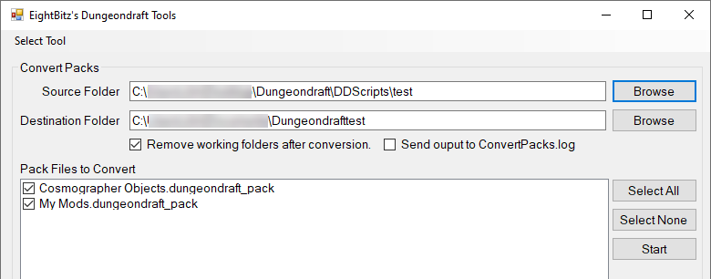

### Start

Start the conversion process.

# Copy Assets

This will present you with the interface for the Copy Assets Tool.

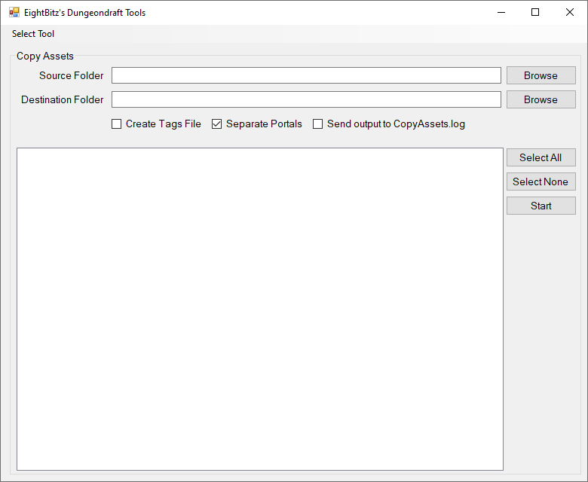

## What Does it Do?

This tool is primarily designed to copy Campaign Cartographer 3 Plus (CC3+) assets into a textures\objects and/or textures\portals folder structure for Dungeondraft. This tool will work for other assets as well, but Campaign Cartographer has two important naming conventions that this tool uses to manage how it copies assets.

## Important Details

This tool will still work for copying assets from a generic source, but if you are copying files from a CC3+ source, you might want to be aware of the following.

### Multiple File Versions

CC3+ has duplicate files of different quality. For instance, if there’s a “House1” image, there will be up to five versions of House1.

* House1_VH.PNG
* House1_HI.PNG
* House.PNG
* House_LO.PNG
* House_VL.PNG

When this tool copies CC3+ assets, it will only copy one version of the file, and that version will be the best quality it can find while completely ignoring _LO and _VL versions. Those are the two lowest-quality versions, and they’re useless in Dungeondraft, so this tool is really only concerned about _VH.PNG files, _HI.PNG files, and .PNG files that are neither _VH nor _HI.

* If all three of those versions exist, only the _VH.PNG version will be copied.
* If only two of those versions exist, the highest-quality version will be copied, whichever one it may be.
* If only one of those versions exists, then of course, that will be the only version that gets copied.

### Portals

CC3+ names doors so their names start with “Door ” or “Doors ”, and it names windows so their names start with “Window ” or “Windows ”.

This tool has an option to “Separate Portals” which, if checked, will copy doors and windows to “textures\portals” instead of “textures\objects”.

## The Controls

### Source Folder

This specifies the folder that contains the folders you want to copy.

As with the other tools, when you select your source folder, the items that appear as checkboxes should be the folders that will become your asset packs. For instance, if I want to copy my Mike Schley assets from my CC3+ folder, I would specify my source folder as “C:\ProgramData\Profantasy\CC3Plus\Symbols\Dungeons”, then I would click the checkboxes for the Mike Schley folders.

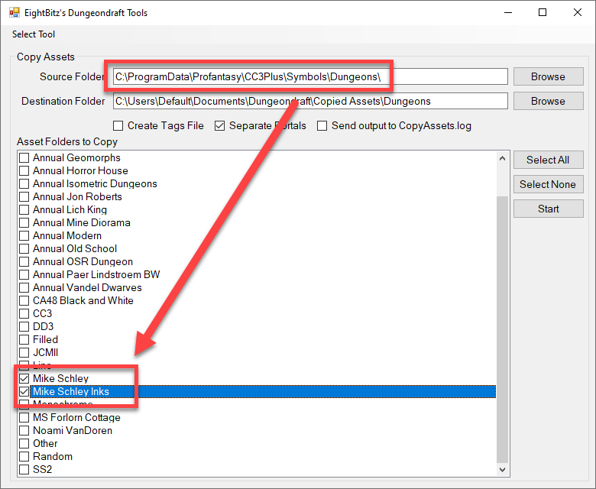

What I don’t want to do is click into the Mike Schley folder and select the subfolders.

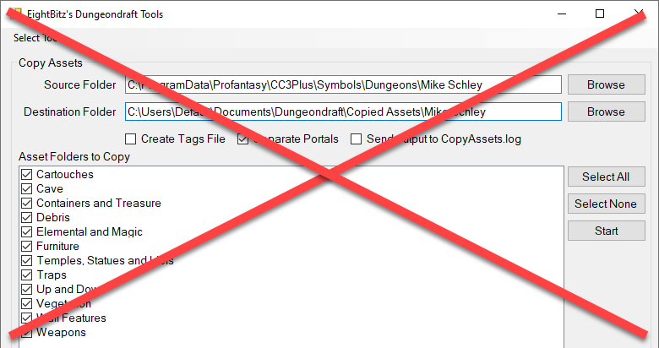

The first method will give me a destination folder structure with “Mike Schley\textures\objects”, then under the objects folder, I’ll have all the subfolders. Cartouches, Cave, Containers and Treasure, etc. That’s what I want my destination folder to look like.

The second method will give me several destination folders that I don’t want.

“Mike Schley\Cartouhes\textures\objects”

“Mike Schley\Cave\textures\objects” (etc)

That second method is what you want to avoid.

### Destination Folder

This specifies the folder that will contain the copied assets.

### Create Tags File

If you check this, then for each folder that is copied, a default.dungeondraft_tags file will be generated and placed in the appropriate data folder for each copied folder.

### Separate Portals

If you check this, doors and windows will be copied to “textures\portals” instead of “textures\objects”.

### Send output to CopyAssets.log

This will save output to a log file named “CopyAssets.log”, in the same folder as DDTools.exe.

# Pack Assets

This will present you with the interface for the Pack Assets Tool.

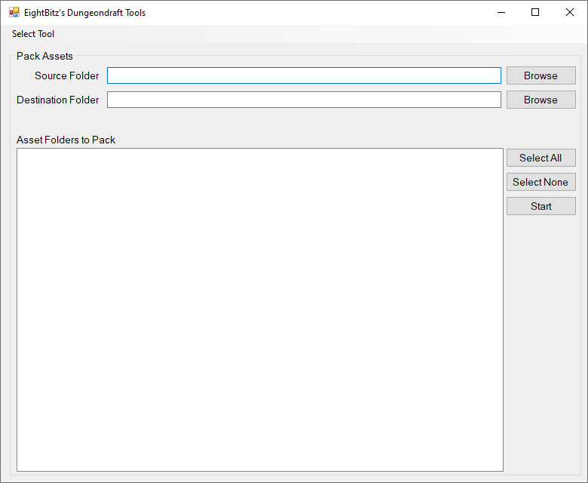

## What Does it Do?

This tool will create .dungeondraft_pack files from selected asset folders.

## Important Details

dungeondraft-pack.exe must reside in the same directory as DDTools.exe

This tool will only create packs for folders that have been previously packed with Dungeondraft. The newest version of dungeondraft-pack.exe can now generate unique IDs for custom asset packs, but I have not incorporated that into the GUI.

## The Controls

### Source Folder

This specifies the folder that contains the asset folders to be packed.

### Destination Folder

This specifies the folder that will contain the packed asset folders.

### Asset Folders to Pack

Once you select your source folder, this will contain a list of folders from which you can select which one(s) you wish to pack. The only folders that will appear in this list will be ones that have a valid json.pack file.

### Start

Start packing the selected folders.

# Unpack Assets

This will present you with the interface for the Unpack Assets Tool.

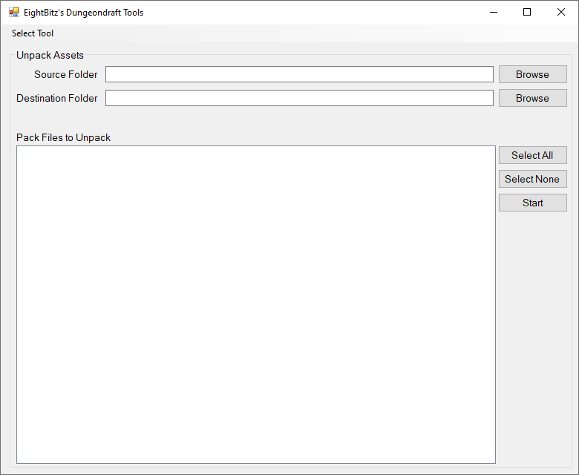

## What Does it Do?

This tool will unpack .dungeondraft_pack files.

## Important Details

dungeondraft-unpack.exe must reside in the same directory as DDTools.exe

## The Controls

### Source Folder

This specifies the folder that contains the .dungeondraft_pack files to unpack.

### Destination Folder

This specifies the folder that will contain the unpacked asset folders.

### Pack Files to Unpack

Once you select your source folder, this will contain a list of .dungeondraft_pack files from which you can select which one(s) you wish to unpack.

### Start

This starts the unpacking process.